**Project Planning Phase**

**Project Planning Template (Product Backlog, Sprint Planning, Stories, Story points)**

|  |  |
| --- | --- |
| Date | 6th July 2024 |
| Team ID | SWTID1720076124 |
| Project Name | Online Complaint Registration And Management System |
| Maximum Marks | 4 Marks |

**Product Backlog, Sprint Schedule, and Estimation (2 Marks)**

Use the below template to create product backlog and sprint schedule

| **Sprint** | **Functional Requirement (Epic)** | **User Story Number** | **User Story / Task** | **Story Points** | **Priority** | **Team Members** |
| --- | --- | --- | --- | --- | --- | --- |
| Sprint-1 | Registration | USN-1 | As a User/Admin/Agent, I can register for the application by entering my email, password, and confirming my password. | 2 | High | Divyanshi |
| Sprint-1 |  | USN-2 | As a User/Admin/Agent, I will receive confirmation OTP once I have registered for the application. | 2 | High | Divyanshi |
| Sprint-2 | Sign- in | USN-3 | As a User/Admin/Agent, I can log into the application by entering email & password | 1 | Low | Divyanshi |
| Sprint-3 | Dashboard | USN-4 | As a user, I can register my complaints and track the status of my registered complaints. | 3 | Medium | Shreya |
| Sprint-3 | Dashboard | USN-5 | As an admin, I can see the user registered complaints and the registered agents available. Then I can assign the agents to the registered complaints and can even update or delete the agent assigned. | 4 | High | Pradeep & Manas |
| Sprint-3 | Dashboard | USN-6 | As an agent, I can view the registered complaints and message the user through message box and change the status of the complaint. | 3 | Medium | Pradeep & Manas |
| Sprint-4 | Complaint Form | USN-7 | As a user, I will mention my name, address and description in the form for registering the complaint. | 1 | Low | Shreya |

**Project Tracker, Velocity & Burndown Chart: (2 Marks)**

| **Sprint** | **Total Story Points** | **Duration** | **Sprint Start Date** | **Sprint End Date (Planned)** | **Story Points Completed (as on Planned End Date)** | **Sprint Release Date (Actual)** |
| --- | --- | --- | --- | --- | --- | --- |
| Sprint-1 | 4 | 2 Days | 6th July 2024 | 7th July 2024 |  |  |
| Sprint-2 | 1 | 1/2 Day | 8th July 2024 | 8th July 2024 |  |  |
| Sprint-3 | 10 | 3 Days | 9th July 2024 | 11th July 2024 |  |  |
| Sprint-4 | 1 | 1/2 Day | 8th July 2024 | 8th July 2024 |  |  |
|  |  |  |  |  |  |  |
|  |  |  |  |  |  |  |
|  |  |  |  |  |  |  |
|  |  |  |  |  |  |  |

**Velocity:**

Imagine we have a 10-day sprint duration, and the velocity of the team is 20 (points per sprint). Let’s calculate the team’s average velocity (AV) per iteration unit (story points per day)

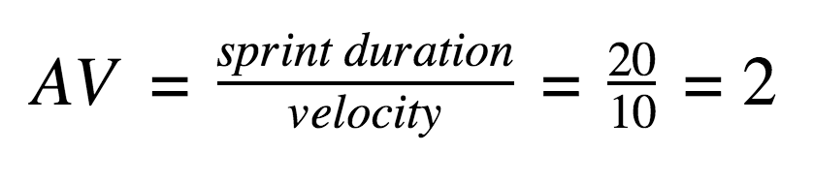

**Burndown Chart:**

A burndown chart is a graphical representation of work left to do versus time. It is often used in agile[software development](https://www.visual-paradigm.com/scrum/what-is-agile-software-development/) methodologies such as [Scrum](https://www.visual-paradigm.com/scrum/scrum-in-3-minutes/). However, burn down charts can be applied to any project containing measurable progress over time.

[**https://www.visual-paradigm.com/scrum/scrum-burndown-chart/**](https://www.visual-paradigm.com/scrum/scrum-burndown-chart/)

[**https://www.atlassian.com/agile/tutorials/burndown-charts**](https://www.atlassian.com/agile/tutorials/burndown-charts)

**Reference:**

[**https://www.atlassian.com/agile/project-management**](https://www.atlassian.com/agile/project-management)

[**https://www.atlassian.com/agile/tutorials/how-to-do-scrum-with-jira-software**](https://www.atlassian.com/agile/tutorials/how-to-do-scrum-with-jira-software)

[**https://www.atlassian.com/agile/tutorials/epics**](https://www.atlassian.com/agile/tutorials/epics)

[**https://www.atlassian.com/agile/tutorials/sprints**](https://www.atlassian.com/agile/tutorials/sprints)

[**https://www.atlassian.com/agile/project-management/estimation**](https://www.atlassian.com/agile/project-management/estimation)

[**https://www.atlassian.com/agile/tutorials/burndown-charts**](https://www.atlassian.com/agile/tutorials/burndown-charts)